**ITN Named Entity Recognizer (NER)**

**Summary:**

During the month of August, our team made significant progress in the development of the ITN Named Entity Recognizer (NER) project. We focused on deepening our understanding of crucial NLP concepts and technologies while also implementing practical solutions using the SpaCy library. Our achievements include refining our foundational model and establishing a clear roadmap for the project's future stages.

**Key Achievements:**

1. Comprehensive Knowledge Acquisition: We dedicated substantial time to studying and grasping essential deep learning and NLP concepts relevant to our ITN Named Entity Recognizer (NER) project. This included delving into Part-of-Speech tagging, lemmatization, word vector representations, and tokenization. Our team's effort in comprehending these concepts laid a solid foundation for the rest of the project.

2. Research Paper Analysis: Throughout the month, we thoroughly examined various research papers related to Named Entity Recognition. This effort allowed us to extract valuable insights and best practices from the academic community. By striking the right balance between theoretical concepts and practical implementation, we ensured that our project would be both well-informed and effective.

3. SpaCy Familiarization and Model Development: We successfully familiarized ourselves with the SpaCy library, a crucial tool in our NER project. Leveraging SpaCy, we developed a foundational Named Entity Recognition model. This model was trained on a pre-annotated dataset, which served as the initial step towards creating a high-performing NER system.

4. Clear Roadmap Definition: One of the key achievements this month was the creation of a well-defined roadmap for the ITN NER project. This roadmap outlines the various stages, tasks, and milestones that we need to accomplish to bring the project to its completion. Having a clear roadmap in place enhances our project's efficiency and ensures that all team members are aligned in their efforts.

**Ongoing Activities:**

1. Model Refinement: While we have developed a foundational NER model, we recognize that there is room for improvement. We will continue refining the model's accuracy and performance to ensure that it meets the desired quality standards.

2. Dataset Enrichment: To enhance the model's capabilities, we are actively working on enriching our training dataset. This involves sourcing additional annotated data and preprocessing it to align with our project's requirements. Advanced Feature Integration: As we progress, we will integrate advanced features into our NER model, such as handling domain-specific entities and fine-tuning the model for optimal performance in the ITN context.

3. Regular Training and Evaluation: We are implementing a regular training and evaluation schedule to fine-tune our model's parameters and monitor its performance. This iterative process will contribute to the continual enhancement of our NER system.

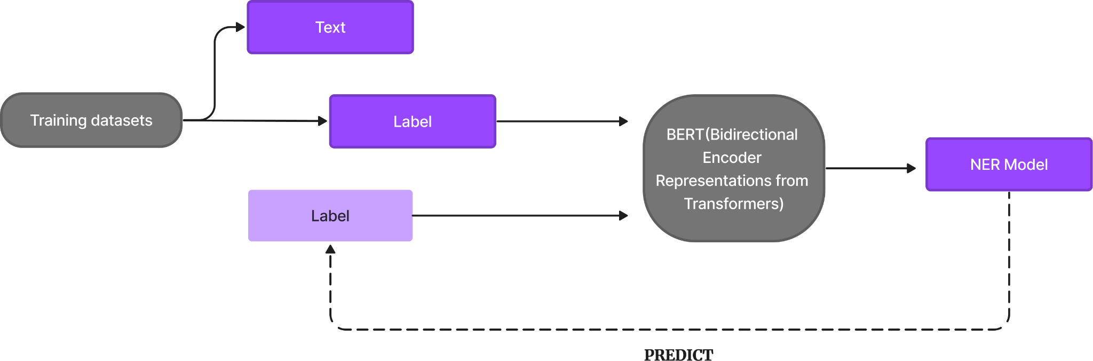

**Challenges Faced:**

1. Data Availability: While working on dataset enrichment, we encountered challenges related to the availability of relevant and high-quality annotated data. We are actively exploring strategies to address this issue.

2. Complexity of NLP Models: The intricacies of NLP models, especially in Named Entity Recognition, posed challenges during the model development process. We are addressing these challenges through close collaboration, research, and knowledge sharing within the team.

**Plan for the Next Month:**

In the upcoming month, we will focus on the following key activities:

1. Model Enhancement: We will concentrate on refining our NER model by incorporating advanced techniques and strategies to boost its precision, recall, and overall performance.

2. Data Enrichment: Our team will continue to work on sourcing and preprocessing additional annotated data to expand and diversify our training dataset.

3. Advanced Entity Types: We plan to extend our model's capabilities by incorporating the identification of specific entity types relevant to the ITN domain.

4. Documentation and Reporting: To ensure transparency and knowledge sharing, we will dedicate time to documenting our progress, decisions, and outcomes, enabling seamless collaboration among team members.

**Conclusion:**

The past month has been productive and insightful, laying the foundation for the successful development of the ITN Named Entity Recognizer (NER) project. Our team's dedication to learning, implementing, and refining NLP concepts and technologies is evident in the progress we have made so far. With a well-defined roadmap in place and a clear plan for the future, we are confident in our ability to deliver a robust and effective NER solution tailored to the ITN domain.

College Professors:

Dr. Ruhul Amin

Email: ruhul@iiitnr.edu.in

Dr. Satyanarayana Vollala

Email: satya@iiitnr.edu.in

Students:

Deepesh Agrawal

Email: deepesh21100@iiitnr.edu.in

Adarsh Nayak

Email: adarsh21101@iiitnr.edu.in

Shikhar Reyya

Email: shikhar21100@iiitnr.edu.in

Date of Report: 25/08/23